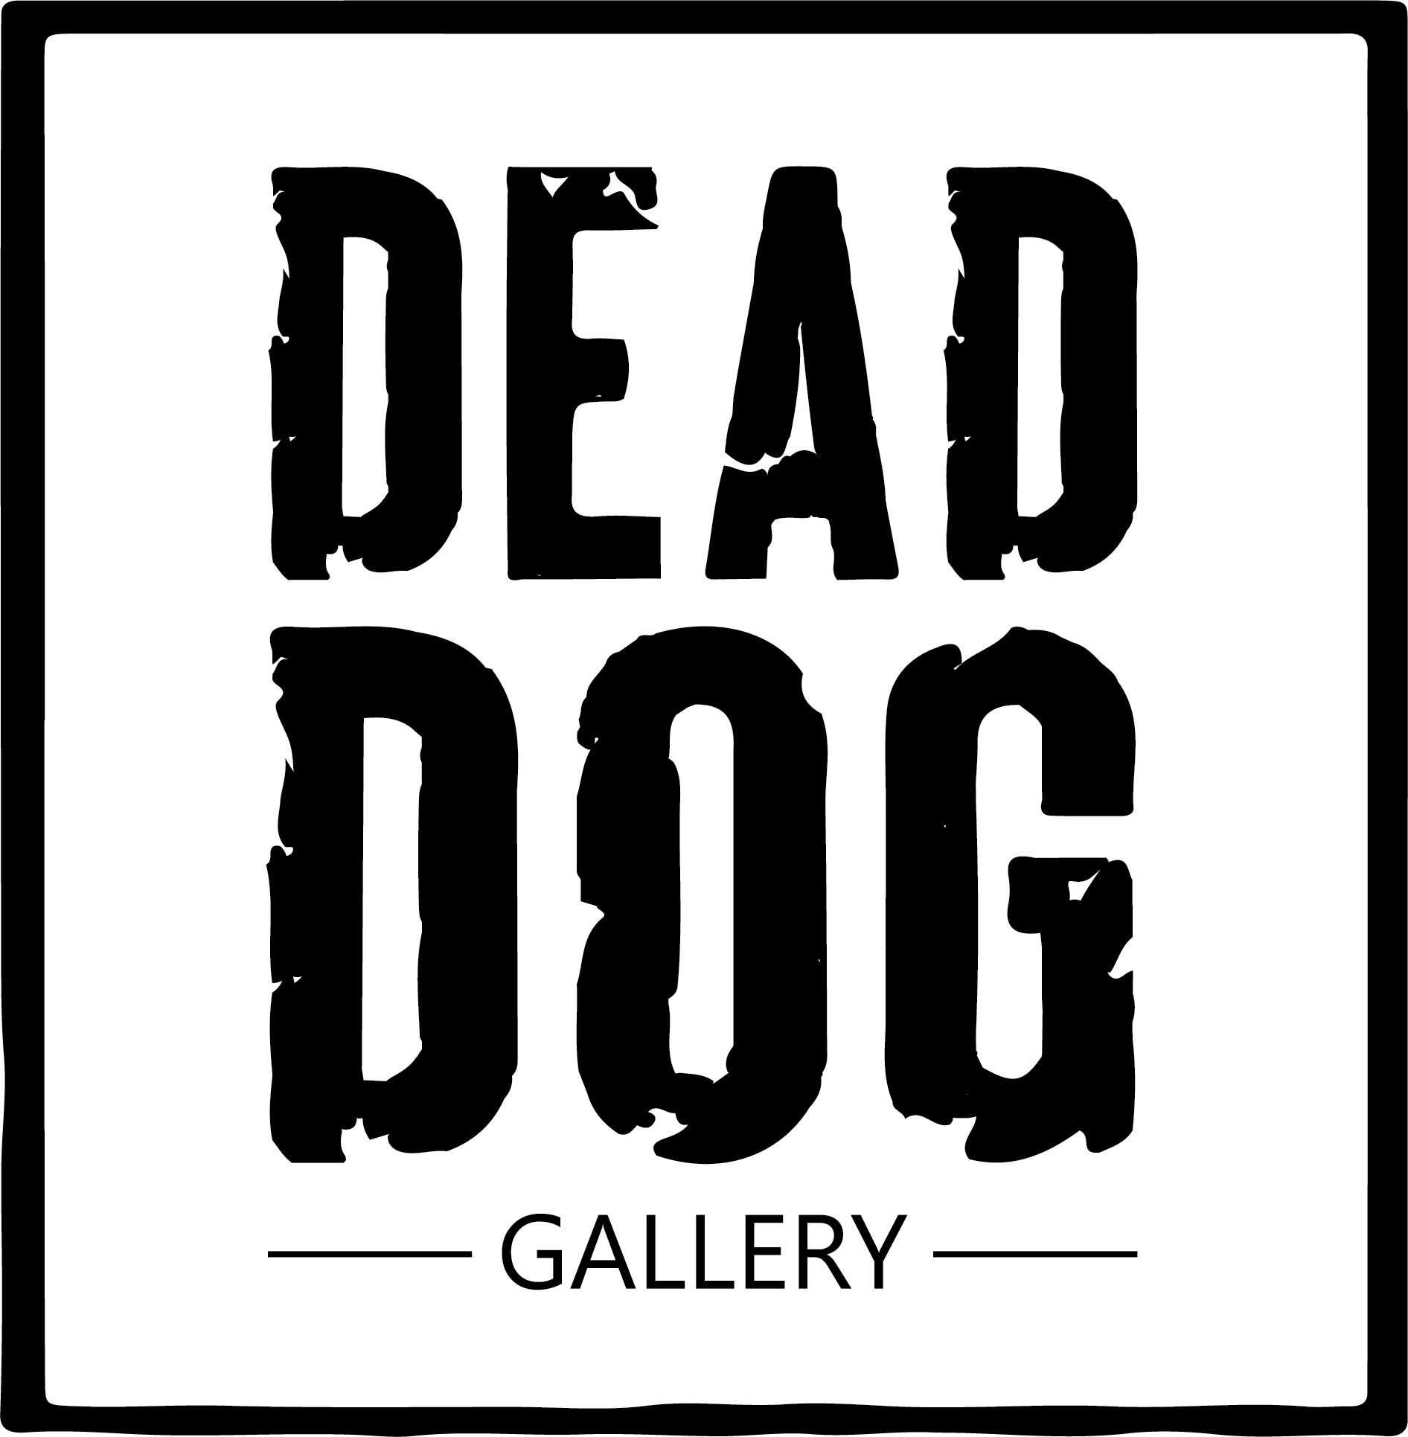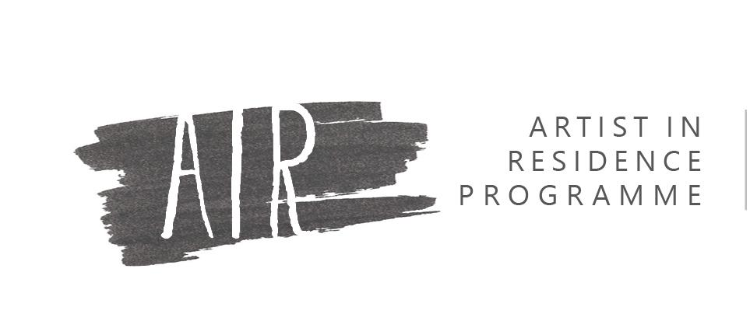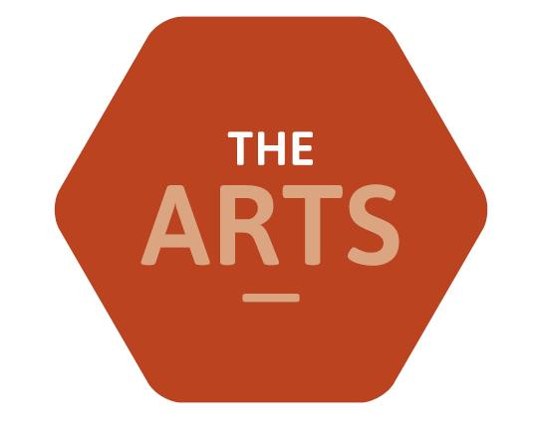

**Durham Sixth Form Centre: Artist Residency Proposal**

| **Name:** |  |
| --- | --- |
| **Phone number:** |  |
| **Email:** |  |

| **Website link:** | |
| --- | --- |
| **Instagram/social media links:** | |
| **Specialism:** | |
| **Proposed residency length:** | |
| **Proposed working days:** | |

| **Artist Statement (250 words max):** |
| --- |

| **What draws you to taking up a residency in an educational setting? (250 words max)**  **Which of the following are you interested in:**  (Tick all that apply or delete as necessary)   * Mentoring / tutoring young people * Working with young people * Community based projects * Participatory artwork * Research based practice * The education sector * Cultural and heritage institutions * Commercial creative industries * Social media and marketing * Other (please outline below)   ………………………………………………………………………………………………………………………………………………………………………………...  **How did you hear about this residency opportunity?**  **We are happy to assist artists who identify as having access needs. Please list any requirements below:** |
| --- |

| **Project proposal:**  Include a working title, concept of the project, and a project plan with a proposed schedule of activities during your residency (over 3 to 6 months, using the template below). Detail technical requirements (equipment, technical support, etc) that you may need. This could be a continuation of an existing project within your practice or a new concept.  **Month 1**  Activity:  Notes:  Materials/support needed:  **Month 2**  Activity:  Notes:  Materials/support needed:  **Month 3**  Activity:  Notes:  Materials/support needed:  *Please add additional months below as required.* |
| --- |
|

| **Supporting imagery:** |
| --- |